Document Tails:

Revision: 2.1

Creation Given: 14/03/2018

Revision Given: 27/04/2018

Document Type: Functional Analysis

PROJECT: DCB - Advanced Authorization Profiling

PHASE: Functional Analysis

|  |  |  |
| --- | --- | --- |
|  | Author | Role |
| Prepared by | Giuseppina Magri - ALTEN |  |
| Verified by | Andrea Gusmini - NEXI |  |
| Approved by |  |  |
| Distributed by |  |  |

Revisions:

|  |  |  |  |
| --- | --- | --- | --- |
| Rev. | Description | Dates | Author |
| 00 | First drawing up of the document | 14/03/2018 |  |
| 01 | Review of the document in which:   * Requirement FUN_08, FUN_09 and FUN_05 are added * in Requirement FUN_04 the relative note to the field has been addition Period of the amount and logic of validity and modification of the field * the examples of the messages of error of Requirement FUN_01, FUN_04 and FUN_06 are added * as a result of integration of new requirement is updated consequently the introduction * Requirement FUN_02 waiting for new Requirement is removed | 26/03/2018 |  |
| 02 | Review of the document in which:   * Requirement in ScaDoc within is added * it is added to the field “additional Services” in the page of management of the profiles | 16/04/2018 |  |
| 2.1 | Review of the document in which:   * as a result of integration of new requirement is updated consequently the introduction * as a result of integration of new requirement is updated Paragraph 7, 8, 9 and 11 * as a result of integration of new requirement is added Paragraph 10 | 04/05/2018 |  |

**External references:**

|  |  |  |
| --- | --- | --- |
| Ref. | Ref. Name | Description |
| 01 | MS_7301_10245_E_10246_E_10245_Abilitazioni.odt |  |
| 02 |  |  |
| 03 |  |  |
| 04 |  |  |

TABLE OF CONTENTS

1 [UPDATE THE TABLE] 4

2 [UPDATE THE TABLE] 4

3 [UPDATE THE TABLE] 5

4 [UPDATE THE TABLE] 6

5 [UPDATE THE TABLE] 7

6 [UPDATE THE TABLE] 8

7 [UPDATE THE TABLE] 9

8 [UPDATE THE TABLE] 10

9 [UPDATE THE TABLE] 11

9.1 [UPDATE THE TABLE] 12

9.2 [UPDATE THE TABLE] 17

9.3 [UPDATE THE TABLE] 17

10 [UPDATE THE TABLE] 18

11 [UPDATE THE TABLE] 19

11.1 [UPDATE THE TABLE] 19

11.2 [UPDATE THE TABLE] 19

# Introduction

The scope of this document is that to describe the new functionalities of application IBK that will be implemented to the aim to allow with the Bank and the user master greater articulation in the management of the powers of signature and usabilità of the produced one.

In particular in the paragraphs that follow the topics will be faced:

* New management of the roll crown of safety regarding the process of signature in addition to how much already previewed from the Bank
* *New interface of User type* of the application IBK

All the listed methods of signature under are subordinated to constraints set up from the Bank with respect to the profiles or groups of qualified users to the signature and the eventual limitations of amount.

Described how much in the following paragraphs takes part of the service of roll crown of advanced safety that must be able to be activated or disabled for the single Bank that chip ax such roll crown. It will have, therefore, to be previewed a parameter in back end (of booleano type) that it returns available all the functionalities that will be introduced in this document only if the Bank has activated the function of advanced roll crown [PRO_02].

The existing roll crown and that introduced in anticipate document will have to be managed also for the authentications that happen on the portal of the Bank, maintaining current the logical ones of management of the profiles (e.g. Bank Saddleback) [PRO_01].

É important to emphasize that, if emerged from the technical analysis particular impacts on the performances of the application, it could be introduced the modality of asynchronous signature or with short temporal suspension in which will be informed the user through appropriate message that the activity is under verification/signature.

# Management Group of Signature with the minimal number of signers [FUN_07]

*BUSINESS REQUIREMENTS*

*It is demanded to make available the possibility for the Bank to indicate, for every group of defined signature, the minimal number of necessary signers for the authorization of the distinguished ones.*

*Such option of roll crown must be been profitable visible is to the operators of Call center (GEB) that on front end (the mask of visualization of the groups of signature).*

ANALYSIS

The possibility allows with the Bank to indicate, for every group of defined signature, the minimal number of necessary signers for the authorization of the distinguished ones.

Besides the menu voice dedicated to the management of the users a new will be introduced through which the user master and the secondary users will have the possibility to visualize the section *Groups of signature*.

In such section a new dedicated field will be added in which the minimal number of demanded signers will be visible (Figura 9).

This last one automatically will be peopled by the Bank and in single visualization; no modification will be allowed with any type of user.

É important to emphasize that such option of roll crown must be been profitable visible also to the operators of the Call center through GEB.

# Management Hierarchical Signature of type [FUN_01]

*BUSINESS REQUIREMENTS*

*It is demanded of being able to manage, in addition to how much previewed from the roll crown of safety passed from Bank (combined signature and limitations of amount), also the modality of hierarchical signature by means of which the precise order is specified in which the various users signers they must add own signature, before distinguished/the disposition can be sent to the Bank.*

*The functionality demands that the user master can attribute to front end to the users who compose a specific Group of Signature an order of action sequence, through the specialization of the visualization mask already anticipates to front end.*

*The possibility is demanded also to manage a variable number of signers*

ANALYSIS

Allows the master user to specify the precise order in which the different signatories belonging to the same group must sign their own signature before forwarding the list or the arrangement to the Bank.

The tables currently present in the Signature Groups section introduced in the previous paragraph, will include a new column in which the master user can select, through a drop-down menu, a progressive number from 1 an, where n corresponds to the total number of signatory users that make up a signature group (Figure 9).

This number indicates the order of action in the signature process and can only be defined by the master user, it will still be available in read only mode to other users.

As the master user chooses a number for each row, in the subsequent ones relative to the other signers of the same group it will be possible to select all the numbers of the combination except those already chosen in the previous lines.

It is important to underline that it is not mandatory to insert a sequenced joint signature but, if the administrator decides to establish a signature order then the same must obligatorily indicate a number of signatories greater or equal to the number indicated by the Bank in the specific field (indicated in the Paragraph 2).

So if for example the petitioner has been associated with the number 2 and the minimum number of signatures required by the Bank is precisely 2, before proceeding with the sending of the bill you will need to sign the second and, if they have not been indicated other signatories by the master user, all the checks related to the security profiling imposed by the Bank will be carried out.

If the checks fail (wrong signature order) an error message will appear in which it will be announced:

• Name, Surname and Tax Code of the Signatory

• Order of signature designated by the administrator with highlighted who of the signatories has already signed

EXAMPLE MESSAGE (UBI style layer type):

WARNING! Wrong order of signature.

Respect the following order:

1. Mario Rossi (Tax Code) ✓ signed

2. Giuseppe Verdi (Tax Code) ✗ has not signed

3. Bruno Bianchi (Fiscal Code) ✗ has not signed

# Management Signature with maximal of amount for period [FUN_04]

*BUSINESS REQUIREMENTS: It is required to manage, in addition to the provisions of the security profiling passed by the Bank (joint signature and limitations of amount), also the signature method with the maximum amount per period, through which it is assigned by the user master to each signatory user a maximum amount per period (daily / weekly / monthly).*

*ANALYSIS*

*Allows the master user to assign to each signatory user a maximum amount per period.*

*The master user, in the user management section, will have the following new fields available:*

|  |  |  |  |
| --- | --- | --- | --- |
| **Field** | **Description** | **Type** | **Unit of measurement** |
| Amount | The maximum amount for period | number | € |
| Period | Period of the amount.  It can assume the values:   * Every day * Weekly magazine * Salary | LOV | x[1] |

Table1 Constraints of amount for period

The fields listed above (see also Figure 6) will be editable by the administrator even after the first entry. During the modification phase the system will show a message through which the master user will be informed that, in case of confirmation of the modification, the counter of the amounts per period will be reset.

EXAMPLE MESSAGE (UBI style layer type):

By changing the amount and / or the period the values ​​for the period already counted will be reset. Confirm the change? (CANCEL / CONFIRM)

It is important to underline that the value of the amount indicated by the administrator will be taken into consideration only for payments and not for collections.

In the signature phase, before proceeding with the sending of the list or the order and before the security profiling checks imposed by the Bank itself, the system will verify that the signatory user in question respects the amount limits per period imposed by the master user.

If the checks fail, an error message will be displayed stating that the maximum amount per period has been exceeded and therefore the list will not be signed.

EXAMPLE MESSAGE (UBI style layer type):

You have exceeded the maximum amount per period, ask for explanations from your Service administrator if necessary.

The list can NOT be signed.

# Management signature for type disposition [FUN_03]

*BUSINESS REQUIREMENTS: It is demanded, also the possibility to manage the limitation on the other dispositive types of proceeds and payment.*

*Call center (GEB), that option on the front of the group of*

*ANALYSIS*

*The possibility allows the Bank to specify for any dispositive types.*

*In the Section "Groups of signature", introduced in the paragraph2 will be added to the new field in which it will be visible in order.*

*Such field automatically will be available only if the Bank previews of the limitations*

*It will be able to define a group of the following:*

|  |  |
| --- | --- |
| **Type distinguished CBI** | **Type dispositive UBI** |
| Buoys - Foreign Discount | Car - Payment stamp car |
| BoEX - Foreign Discount XML | BFis - Discount for detr. Treasurer |
| EFF - Payment/refusal effects | BolB - Bulletin post. blank |
| F24 -Payment F24 delegations | BolP - Bulletin post. premarked |
| Frec - P. bulletins Arrow | BOnl - Discount Online |
| Turn - SCT giroconti and girofondi | CBILL - CBILL/PagoPA payment |
| MAV - M.Av proceeds. | MrAV - M.Av Payment. /R.Av. |
| RiBa - Proceeds Received Bank | RCar - prepaid paper Recharges |
| SCT - Discount SEPA Credit Transfer | Rtel - It recharges telephone |
| SDD - SEPA Direct Debit |  |
| Stip - SCT emolument |  |
| URGP - Urgent discount |  |
| Checks XML Italy |  |

Table2 dispositive Types

*N.B.* The listed technical forms over will be able to endure of the variations in case of new functionalities.

É important to emphasize that such option of roll crown must be been profitable visible also to the operators of the Call center through GEB.

# Management identifying signature for [FUN_06]

BUSINESS REQUIREMENTS: It is required to make available the possibility for the master user to enable for each secondary user the signature functionality for one or more groups of master data, in addition to the authorizations already defined in the operating profile of each user.

This specific group type must only be managed by the administrator of the workstation and may not coincide with the management of the groups already available in the address book.

The management of the new group of personal data must be defined at the user level and verification of the authorization must take place exclusively at the signature level and not during the generation / import phase of the list.

The control on the recipient's registry varies according to the technical form of the provision that must be signed (for the VAT collection / Cod. Fisc., While for the payments code IBAN / BIC).

ANALYSIS

Allows the master user to enable for each sub-user the signing functionality for one or more groups of master data.

In the user management section, the administrator will have the opportunity to indicate in the appropriate new field the group of personal data for which the user in question is authorized to sign.

This is a drop-down menu in which there will be a list of groups created in master data by the master user, if they exist.

It will also be possible to assign multiple groups of personal data to the same signer through the appropriate button.

In the Phonebook section, on the other hand, a new field will be provided in which the master user can create groups of personal data enabled for the signature.

This field will follow the same logic of the Group field currently present in the Address Book and will be visible only to the master user.

To create a new group of personal data (Address Book), refer to the document "MS_7301_10245_E_10246_E_10245_Abilitazioni.odt".

In the signature phase, before proceeding with the sending of the bill or the layout and before the security profiling checks imposed by the Bank itself, the system will check if the user is authorized to sign the specific personal data available according to the various device types (eg SCT → suppliers sepa, F24 → payers, SCT fees → employees, etc.).

In particular, control logics will be implemented according to the fields indicated in the following table, which shows:

* *Type of bill / arrangement: indicates the technical form of the bill or the provision*
* *Key field: identifies for which unambiguous key of the registry entity the check must be carried out*

|  |  |
| --- | --- |
| **Distinguished type/disposition** | **Field key** |
| Buoys - Foreign Discount | IBAN/CC/BIC |
| BoEX - Foreign Discount XML | IBAN/CC/BIC |
| F24 -Payment F24 delegations | Tax code/VAT number of the contributor |
| Turn - SCT giroconti and girofondi | IBAN |
| RF24 - Revocation F24 delegations | Tax code/VAT number of the contributor |
| RiBa - Proceeds Received Bank | Tax code/VAT number of the debtor |
| SCT - Discount SEPA Credit Transfer | IBAN |
| SDD - SEPA Direct Debit | IBAN |
| Stip - SCT emolument | IBAN |
| URGP - Urgent discount | IBAN |
| BFis - Discount for detr. Treasurer | IBAN |
| BolB - Bulletin post. Blank | Postal number CC |
| BOnl - Discount Online | IBAN |
| RCar - prepaid paper Recharges | Number of the paper |
| Rtel - It recharges telephone | Mobile number |

Table Logical of control in case of signature for identifying

*N.B. The technical forms listed above may undergo variations in case of new features.*

*A note will be provided in which the user will be informed that to check for which types of devices a check is envisaged, it will be necessary to refer to the Help page.*

*In the event of a negative outcome of the checks, instead, the system will show an error message in which it will be specified that the signer in question is not authorized to sign for one or more lists of the list.*

*Particularly in the message will have to be listed:*

*• Progressive number of the provision*

*• Amount of the provision*

*• Company name of the registry for which the petitioner is not authorized*

*EXAMPLE MESSAGE (UBI style layer type):*

*WARNING! You are not authorized to sign for the following data (s):*

*1. Number of the disposition of the amount of the company name*

*2. Number of the disposition of the amount of the company name*

*3. Number of the disposition of the amount of the company name*

EXAMPLE MESSAGE (of type layer in style UBI):

ATTENTION! You are not qualified to sign for and following, etc. /i anagrafica/he:

1. *Number disposition Amount Corporate name*
2. *Number disposition Amount Corporate name*
3. *Number disposition Amount Corporate name*

# Management of the modality of activation of Mobile App [FUN_08]

*BUSINESS REQUIREMENTS:* *It is demanded to make available the possibility for the user master to qualify for every secondary user, in addition to the qualifications already defined in the operating profile of every user, the modality of activation of Mobile the App new of Nexi Digital Corporate.*

*Such functionality will have to be realized through a new and specific section of the form of roll crown, being profitable available two distinguished options of configuration of the App:*

* *Base*
* *Been left over*

*The information will have to be analogous memorized, dealt and transferred to all the others managed by the operating roll crown of the users.*

ANALYSIS

Master to activate allows with the user, for every secondary user, the new Application (App) for the Mobile banking that Nexi Digital Corporate (NDC) will put on for the customers who possess a smartphone.

In the section of management of the users a new field will be previewed in which the user master it will have the possibility to qualify the secondary user to the mobile version of the application one. Such field will have to be visible only if the Bank has accepted the service of Mobile App Banking.

Through a menu to curtain it will be, moreover, possible to specify the type of profile to associate the secondary user, to chosen between two possible options of configuration:

* Base
* Been left over

While for the secondary user of default the profile will not be valued, for the administrator it will be valued as “Advanced” and he will not be editable.

Such configuration will have to be inherited from the mobile application.

# Management given of contact for shipment notifications via email and/or push on App [FUN_09]

*BUSINESS REQUIREMENTS:* *It is demanded to make available the possibility for the user master to insert, for every user secondary signer and/or, the data of contact for useful the shipment from IBK and/or NDC of notifications via email and/or notifications push to the new Mobile App NDC.*

*Such functionality will have to be realized through a new and specific section of the form of management of user, being profitable available two distinguished fields of insertion of the data:*

* *Email*
* *Mobile number*

*“Field email” ~~for the Users Signers will have to turn out exclusively of visualization, since is transmitted directly by the Bank via computerized flow, while for the Secondary Users~~ modification will have to be editable in insertion//cancellation.*

*The field “mobile number” will have to be editable in /modifica/cancellazione insertion ~~is for the Users Signers that for the Secondary Users.~~* *The data “mobile number” will be the same one used also for the procedure of enrolling of the new Mobile App NDC.*

*In case of insertion/modification of the content of the fields will have to be applied the specific controls of formatting.*

ANALYSIS

Master to indicate allows with the user, for all the users (secondary administrator and), the data of contact available for the shipment of notifications via email from IBK and/or NDC or notifications push to NDC Mobile the App new.

In the section of management of the users (Figura 2) two new fields will be put on of the user master:

* Email
* Mobile number

Such fields will be always editable to prescind from the type of user who is shaping himself and could be used also for future functionalities tied to the evolutions in mobile within and/or new additional services.

In phase of insertion or modification of the listed fields over standards will be implemented of the controls that in general terms are previewed for this genre of fields.

# New interface of configuration IBK [FUN_05]

*BUSINESS REQUIREMENTS:* *The improvement of the process of configuration of the operating profiles and the secondary users is demanded, in way to logically from each other make available a modality in style wizard that it guides the user master, through which concatenated next steps, in the creation of the secondary users and in the configuration of the operating profiles to attributed they.*

*The new interface will have to be available not only for versions UBI but also for those IBK standard.*

ANALYSIS

A king-styling of the graphical interface of IBK is previewed, with the twofold objective to improve the aspect and to simplify the several iterances of the application one being returned them of *User* type.

In particular in this paragraph it will be illustrated the new process of configuration of the users and the section Groups of signature with the details of the new fields introduced in the paragraphs precedence.

É important to emphasize that the functionalities tied to the management and creation of the profiles will be included in the relative section to the management of the users.

In particular it will be possible to create new profiles in the phase of creation user while shielding dedicated to the management of the profiles (identical to that already existing) in the section of management of the users will be previewed (Figura 1).

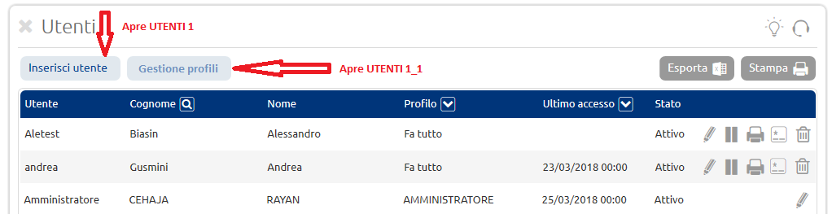

Figure1 Management profiles

The functionalities tied to the Groups of Signature will be accessible, instead, through a new menu voice.

N.B.*The contained descriptions in the shielded ones that they follow will have to be modifiable without to demand a release necessarily as for example currently it happens for the present descriptions in the pages of Help.*

## Creation of secondary users (like UBI)

For the creation of a new secondary user, after to have selected the button *You insert user,* the administrator will on hand have the following dedicated mask:

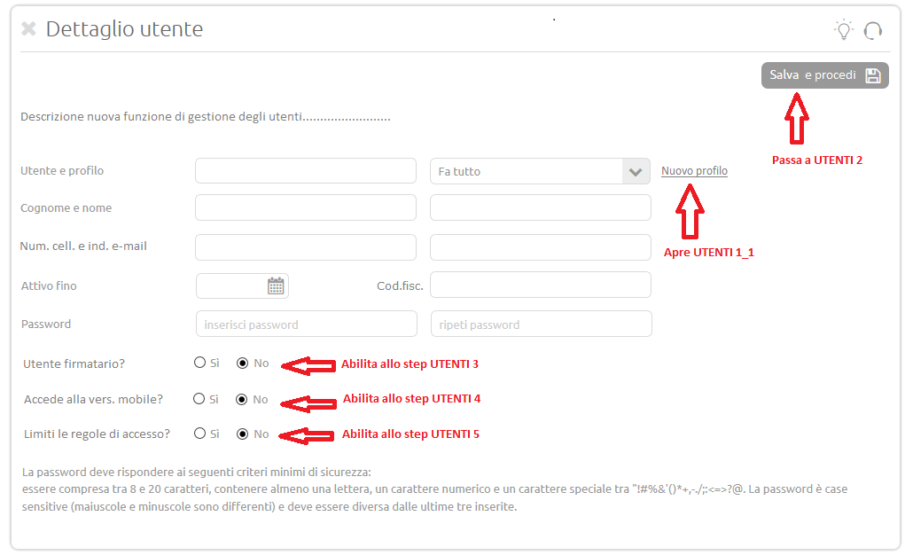

Figure2 USERS 1

In this phase the user master will have to insert the personal identifying data of the user and the relative qualifications.

The field Tax code will be always editable and could be used for services additional future (sees BR FUN_12).

Through the selection of the *New* voice *profile*, will be shown the following POP-up in which administrator it will have the possibility to directly shape a new profile in this phase.

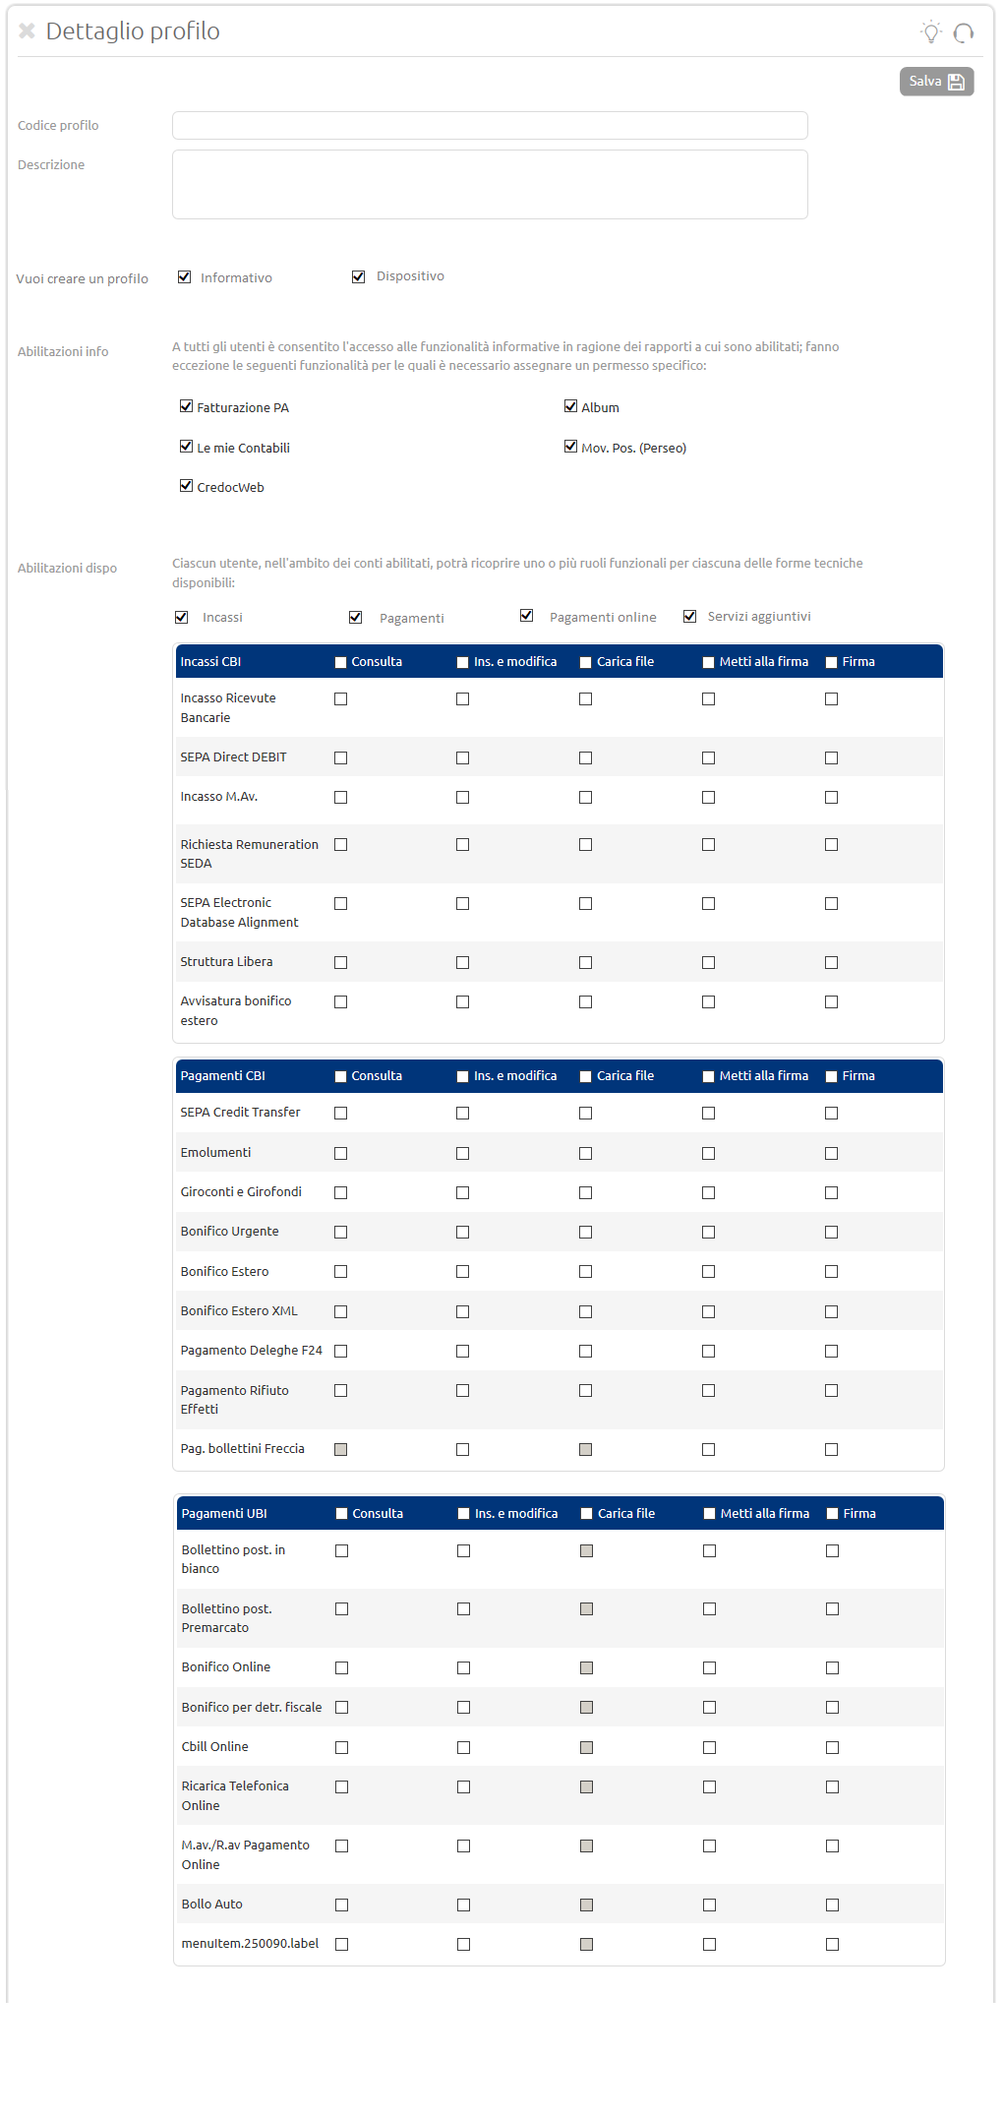

Figure3 USERS 1_1

The several portions of such page will not be shown of default for entire but they will follow of logical of visualization the particular ones:

* To the opening (after the selection of the New field Profile) will be shown to blade the first part of the shielded one, that relative to the Code Profile, Description and type of qualification (Informative/Dispositive).
* According to the choice of the user the next portions of the page will be shown. If, therefore, the user has selected the *Informative* voice will be only shown the relative part to the informative qualifications, vice versa if she has selected the *Dispositive* voice visualizes the section of the dispositive qualifications.

If the profile is qualified to both the functionalities, the administrator will have to select both the voices and will be shown all and the two sections.

In particular, in the part dedicated to the dispositive qualifications the fields additional Proceeds, Payments, Payments online and/or Services (if you anticipate) of default are unchecked and the respective below tables are shown in relation to the selected voices. Therefore if for example the administrator has selected the voices Payments and Payments online will visualize only the two relative tables to the payments.

After to have completed the configuration of the new profile and to have carried out the rescue of the modifications through the appropriate button, of new the detail page will be shown to the user master user (Figura 2) in which the field *Profile* it will be peopled automatically with the profile as soon as created.

Clicking on the button “It saves and you proceed”, the following mask in which the same one will be shown to the user master it will be able to define or more society to qualify to the user who is shaping; of default all the societies will be qualified:

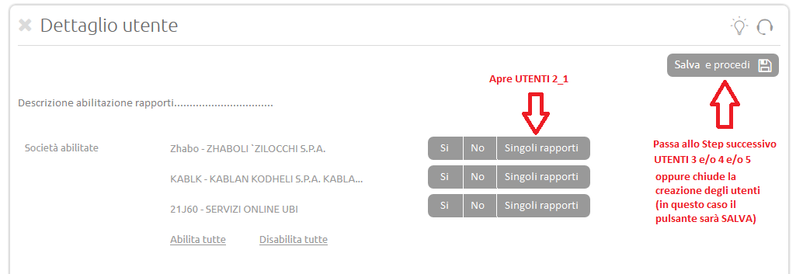

Figure4 USERS 2

In particular if the administrator chose a qualification for single relationships[2] has the possibility to select the single qualifications through a page to layer, that is:

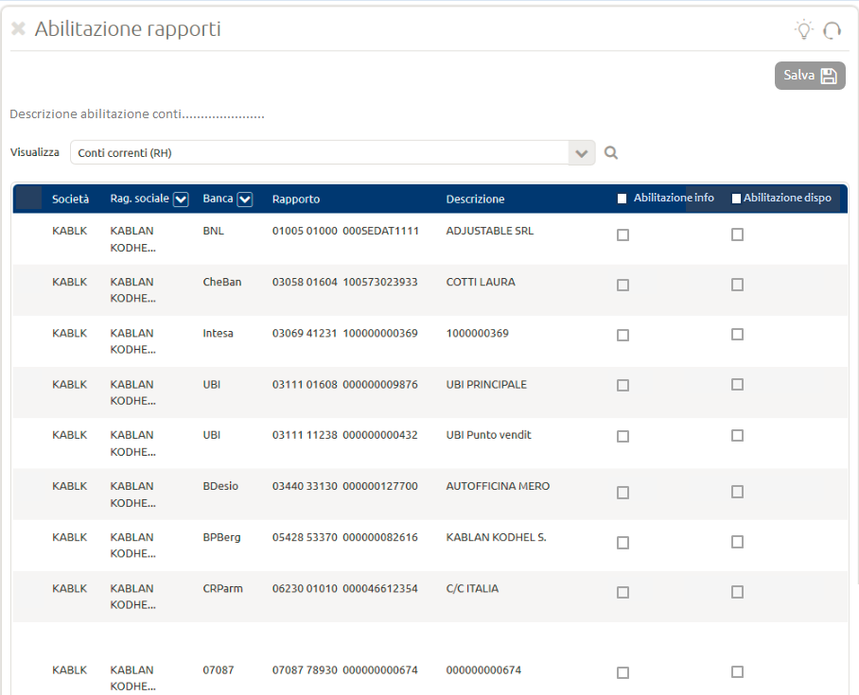

Figure5 USERS 2_1

The administrator, in the same one videata shown inFigura 2 has moreover the possibility to define, through the fields that follow, ulterior aspects to qualify to the user:

* User Signer (SI/NO)
* It approaches the Vers. piece of furniture (SI/NO)
* You limit the rules of access (SI/NO)

Of default, in phase of creation, such fields will be set up NOT.

The functionalities that will set up to, instead, will have to be obligatorily personalized in the next phases (after to have selected It saves and you proceed), as shown in the figures that follow:

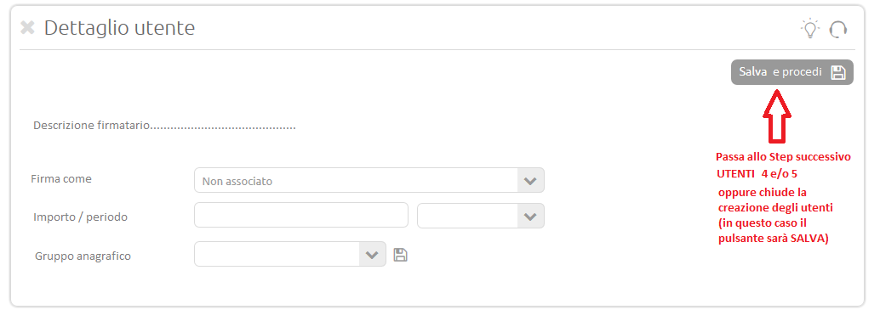

Figure6 USERS 3

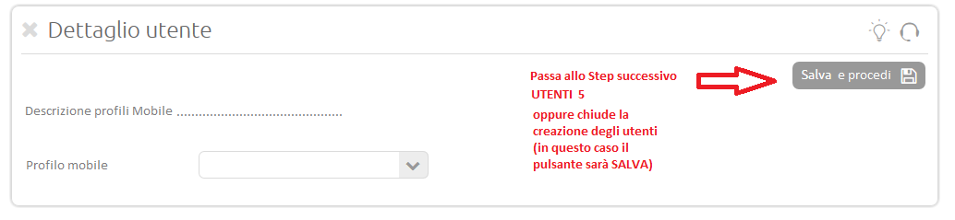

Figure USERS 4

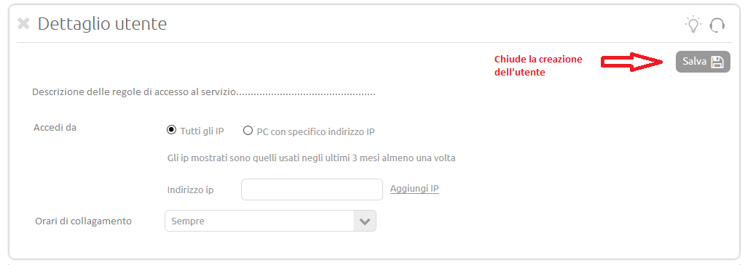

Figure USERS 5

Based on the configuration chosen from the user master, the last step aerobic will have only the button “Saves”.

After the final rescue the profile of the secondary user in any case remains editable from the user master.

It is important to evidence that, in case of modification user the system will before show the fields cited (User signer, Approaches the Vers. Piece of furniture, Limits the access rules), already peopled based on the configuration of the already existing user and, moreover, in phase of rescue, in case of modification from NOT, the system will inform the administrator who, if the modification will be confirmed, the inserted specific information (Figura 6,Figura 7 e)Figura 8 will go lost.

EXAMPLE MESSAGE (of type layer in style UBI):

ATTENTION!

Modifying from the relative qualifications to /e sezione/i (the XXXX[3]) they will not be gone lost. It confirms of wanting to proceed? (ANNULLA/CONFERMA).

## Creation of secondary users (not like UBI)

The section of management of the users, so as described in the paragraph9.1 it will have to be extensive to all the Banks that currently use IBK standard but with a various interface from that like UBI.

All the new fields introduced in this document will have to be added to the fields already anticipate in the interface standard of the other Banks that will assume the lines guides and the usabilità of that UBI.

*For the financial institutions that have of the service of FastInvoice* it will have to preview an ulterior question in the which showed shielded one inFigura 2 (as those already you anticipate of type SI/NO) and, if set up to, the service will have to be configurabile through an ulterior step aerobic of personalisation in which the user it will have to select the codes IS of the enterprises that will have of such service.

É important to emphasize that the fields currently you anticipate in the IBK standard of the several Banks but that they are not you anticipate in that of type UBI will not endure variations but faithfully they will be brought back in the new interface (e.g disabilita detail and management salaries, qualification to the new relationships,…).

As from fine BR [FUN_10] the granular roll crown and (Consults, Ins. and Modification, Charge rows,… -Figura 3) will have to be extensive also to the Banks that use IBK with interface standard (not like UBI) and that they activate the service of advanced roll crown.

## Groups of signature

As anticipated in the paragraphs precedence the relative section to the Groups of signature will be accessible to the user master and the secondary users through a new menu voice.

Such section will be so composed:

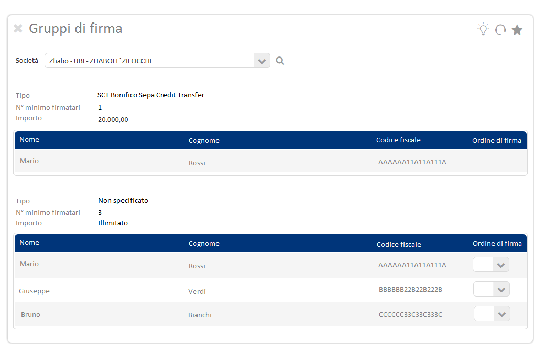

Figure Groups of Signature

Through the field *Society* it will be possible to search the groups of signature leaking for corporate name.

Many tables will be previewed how many are the groups of signature and in every table many lines will be previewed how many are the signers.

The fields *Type* (that they will have to be converted in format Alias + Description you form technique), *the minimal N° signers* and *Amount* automatically will be peopled by the Bank through GEB and they will not be editable.

If the bank agency then does not send some restriction on the dispositive type the field *Type* will be valued with *Not specified* while, for the field *Amount*, if the Bank does not preview some limitation (999.999.999) then will be of *Limitless* type as in the example (Figura 9).

The field *Order of signature*, instead, will be editable exclusively from the user master through a menu to curtain.

This last one will not be present if the group is composed of a single signer.

When previewed in this paragraph it will have to be extensive also to the Banks that use IBK standard (not like UBI).

# Exposure of the services of roll crown [FUN_11]

*BUSINESS REQUIREMENTS:* *It is demanded of being able to expose of the roll crown services to the aim to make available them to other external services*

É realized a first version DRAFT of the relative API Specification Opens to the roll crown services that will be made available for the new services.

Such detailed lists are under update.

# Personalisation SCADOC [FUN_12]

In this paragraph the new process of configuration of the users will be illustrated to qualify to the Area of Documentary Exchange (is side Enterprise that side Manager Bank) previewing an eventual roll crown of specific safety (you see paragraph5).

## Profilazione side Customer

*BUSINESS REQUIREMENTS:* *If the bank chip ax the service of documentary exchange must be possible to outline for this service the relative ones permission (consults/modification).* *It is moreover demanded to add between the launches you live of management of the user also the tax code of the secondary user.*

ANALYSIS

In the section of management of the profiles (you seeFigura 3), the administrator will have the possibility to qualify the user who is shaping uses it of the area of Documentary Exchange through an appropriate new section (Figura 10) mail beneath of the tables already anticipates in the page and that place up between the dispositive qualifications available will be shown after the selection of the field *additional Services*.

Such section will have to be visible only if the Bank has accepted the service of Documentary Exchange.

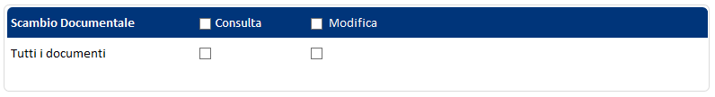

Figure ScaDoc Qualification

Such configuration defined in IBK will come acquired through the roll crown services that will be exposed (OAS).

In an optical of Minimum Viable Product (MVP) the possibility will be previewed to qualify the user to the single consultation or the modification that the possibility includes to consult, to enclose documents, to sign them or eventually to start communications with the Bank for all managed documents.

In the TARGET version, instead, the administrator will have the possibility to specify the same functionalities in relation to the macros document categories that will be defined.

## Profilazione side Manager (TBD)

*BUSINESS REQUIREMENTS:* *The possibility is demanded to define for the users of the Bank a series of permission of accessibility to the area of documentary exchange in relation to the business organizational chart.*

In MVP an only profile is previewed exclusively Manager with the qualification to all the present ScaDoc functionalities in MVP.

In TARGET optical, instead, different profiles with a series of permission will be defined of accessibility to the data of the area of Documentary Exchange in relation to the business organizational chart.

1. Independently from the hour/day of insertion or modification of the field the system will verify that the amount is not exceeded in the indicated period, that is:

   If Every day the control will be carried out on all the 24 hours of the same day.

   If Weekly magazine the system will hold account of the period between the monday and the Sunday (comprised) of the same week.

   If, instead, Salary will have to be considered all the running month (from the first to the last day of the month, comprised ends).
2. To return the pulsantiera usable in which, through an adapted coloration, it is easy to have a premonition the qualified case.
3. (XXXX): Variable field in function to the choice of the user. It can assume the values: User signer, Approaches the Vers. Piece of furniture and Limits the access rules.

   If the modification of the administrator impattasse more sections to list the impattati fields separated by a comma.